EX NO:1 | ELECTRICITY BILL
DATE: | ELECTRICITY BILL

AIM:
To develope a java console apllication to generate electricity bill with consumer no, consumer name, previous month reading and present month reading and EB type connection and display the result.

REQUIREMENT:
Create a class electricty bill with the following data member, customername, previous month reading, current month reading and type of EB connection, member function: read the value, compute the value, print the value.

ALGORITHM:
STEP 1: Declare a package electricty bills.
STEP 2: Declare a class name of electricity bills.
STEP 3: Declare a contruction with initial attribute.
STEP 4: Declare get data member and member function.
STEP 5: Delare class calculation, with a static main function.
STEP 6: Create object by with consumer name, consumer no, previous month reading,
present month reading.
STEP 7: Get input from user.
STEP 8: Calculation thw total eclectricity bill.
STEP 9 :Display result.
CLASS DIAGRAM:

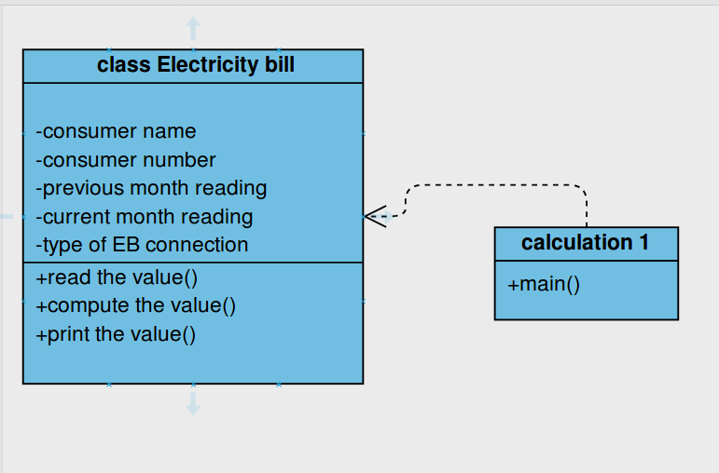

PROGRAM:

/**
Devlope by,
*D.Panneerselvam
EEE 3RD year,
*saveetha engineering college
*selvamdps@gamil.com
/*
package elecricitybills;
import java.util.Scanner;
public class ElectricityBills {
private long customernumber;
private String customername;
private long previousmonthreading;
private long currentmonthreading;
private String customertype;

public ElectricityBills()
{
this.customernumber=1001;
this.customername="unknown";
this.previousmonthreading=100;
this.currentmonthreading=120;
this.customertype="domestic";
}

public ElectricityBills(long number,String name,long reading1,long reading2,String type)
{
this.customernumber=number;
this.customername=name;
previousmonthreading=reading1;
currentmonthreading=reading2;
customertype=type;
}
public void getdata()
{
Scanner sc=new Scanner(System.in);
System.out.printf("\n%40s","BILLING INFORMATION");
System.out.print("\nEnter the customernumber:");
this.customernumber=sc.nextLong();
System.out.print("Enter the customername:");
this.customername= sc.next();
System.out.print("Enter the Previous Month Reading:");
previousmonthreading=sc.nextLong();
System.out.print("Enter the Current Month Reading:");
currentmonthreading=sc.nextLong();
System.out.print("Enter the Customer type (Domestic,Commercial):");
customertype=sc.next();
}
public void printData()
{
System.out.println("CustomerNumber:"+customernumber);
System.out.println("CustomerName:"+customername);
System.out.println("PreviousMonthReading:"+previousmonthreading);
System.out.println("CurrentMonthReading:"+currentmonthreading);
System.out.println("Customertype:"+customertype);
}
public void computeBillamount()
{
long unit=currentmonthreading-previousmonthreading;
double billAmount;
billAmount=0;
String spacing="------------------------------------------------------------------------------------";

if(customertype.equals("Domestic"))
{
if((unit>=0)&& (unit<=100))
{
billAmount=unit*1.0;
}else if((unit>=101)&&(unit<=200))
{
billAmount=unit*2.50;
}else if((unit>=201)&&(unit<=500))
{
billAmount=unit*4.0;
}else
{
billAmount=unit*6.0;
}
}else if(customertype.equals("Commercial"))
{

if((unit>=0)&& (unit<=100))
{
billAmount=unit*2.0;
}else if((unit>=101)&&(unit<=200))
{
billAmount=unit*4.50;
}else if((unit>=201)&&(unit<=500))
{
billAmount=unit*6.0;
}else
{
billAmount=unit*7.0;
}
}
System.out.print("\n"+spacing+"\n");
System.out.printf("%40s", "SALE BILL");
System.out.print("\n"+spacing+"\n");
this.printData();
System.out.printf("%29s%8.2f Rs", "Total Amount:",billAmount);
System.out.print("\n"+spacing+"\n");
}
}

CALCULATION:

package electricitybills;

public class Calculationforbillings {

public static void main(String[] args) {
// TODO Auto-generated method stub
ElectricityBills E1,E2;
E1=new ElectricityBills(1001,"Arun",90,110,"Domestic");
E1.printData();
E2=new ElectricityBills();
E2.getdata();
E1.computeBillamount();
E2.computeBillamount();
}

}

OUTOUT:

CustomerNumber:1001
CustomerName:Arun
PreviousMonthReading:90
CurrentMonthReading:110
Customertype:Domestic

BILLING INFORMATION
Enter the customernumber:34
Enter the customername:456
Enter the Previous Month Reading:123
Enter the Current Month Reading:321
Enter the Customer type (Domestic,Commercial):Domestic

------------------------------------------------------------------------------------
SALE BILL
------------------------------------------------------------------------------------
CustomerNumber:1001
CustomerName:Arun
PreviousMonthReading:90
CurrentMonthReading:110
Customertype:Domestic
Total Amount: 20.00 Rs
------------------------------------------------------------------------------------

------------------------------------------------------------------------------------
SALE BILL
------------------------------------------------------------------------------------
CustomerNumber:34
CustomerName:456
PreviousMonthReading:123
CurrentMonthReading:321
Customertype:Domestic
Total Amount: 495.00 Rs

RESULT:
Thus the java application is generated successfully.

